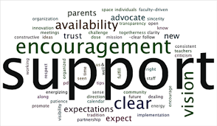 | Company Name | Kate Kissee, Elementary School Counselor  417-634-3223 ext. 168  Gerald Chambers, Elementary Principal  417-634-3223 ext. 126 | Community Resources  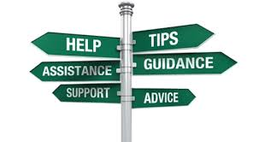

Counseling Services  Burrell Behavioral Health 417-269-5400  Counseling Solutions 417-887-9950  Missouri Victims Center 417-863-7273  Ozarks Counseling Center 417-869-9011  Center City Counseling Clinic 417-836-3215  Touch Stone Counseling 417-581-6911  Christian County Counseling 417-725-8810  County Emergency Offices  Christian County Department of Social Services 417-581-7511  Christian County Sheriff’s Department 417-581-2332  Prosecutor’s Office 417-581-7915  Juvenile Office 417-581-7274  Hotlines and Emergency Services  Burrell Crisis Line 800-494-7355  Suicide Prevention 800-784-2433  Poison Control 800-222-1222  Missing & Exploited Children 800-843-5678  MO Abuse & Neglect 800-392-0201  Domestic Violence 866-383-3733  Isabel’s House 417-865-2273  Harmony House 417-837-7700 | Without a sense of caring, there can be no sense of community.  -Anthony J. D’Angelo  Substance Abuse Help  Carol Jones Recovery Center (Women) 417-862-3455  Sigma House  Ozark 417-581-9464  Branson 417-335-5946  Springfield 417-862-3339  Adolescent C-Star 417-269-0300  Centers for Addiction 417-269-2273  Local Housing Resources  Nixa Heights 417-725-2911  Apple Heights 417-725-2832  Highland Heights 417-725-9522  Riverside Heights 417-581-6499  Help Lines  Legal Aid 800-444-4863  Child Support Enforcement 417-895-6338  Parent Link 800-552-8522  Focus on What You Do Best  You might try a summary of competitive benefits at left and a brief client success story or some of those glowing testimonials here in the middle. | Help Lines Cont’  Smile Center 417-582-5432  Cox North Adolescent 417-269-3275  Lakeland Hospital 800-432-1210  Child Advocacy Center 417-831-2327  Victim Center 417-864-7322  Support Services  OACAC 417-581-7631  WIC-Women, Infants & Children 417-581-2385  Christian County Health Dept. 417-581-7285  Parents as Teachers  Sparta 417-634-3224 ext. 3111  Ozark 417-582-5992  Nixa 417-724-3850  NAMI (Mental Illness Support) 417-864-7119  Family Violence Center 417-864-7233  Missouri Career Center 417-887-4343  Grief Counseling  Lost and Found 417-832-9423  Compassionate Friends 417-887-7089

